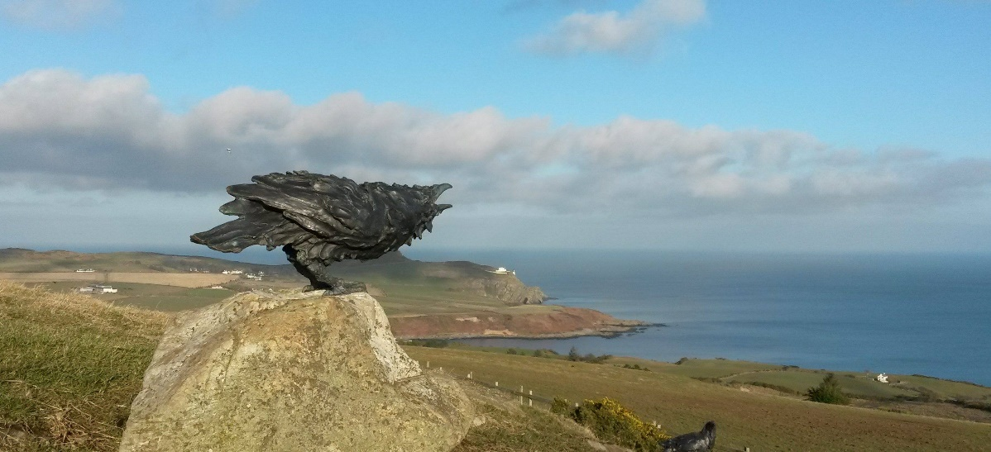 |  | GARFF  - COMMISSIONERS  - Newsletter  May 2018
DELIVERING LOCAL AUTHORITY SERVICES TO THE RESIDENTS OF |  | lAXEY LONAN MAUGHOLD

Robert ‘Bobby’ Moughtin.
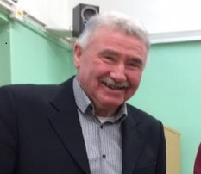
It is with great sadness that the Commissioners have to report the passing of Robert “Bobby” Moughtin.
The Commissioners were very saddened at news of the passing of Robert Moughtin early in the year. Robert served on Maughold and latterly Garff Commissioners for over 12 years. He had a great wealth of political knowledge gained locally and nationally which enabled him to participate in discussions and represent his constituents at all levels. His time with the Commissioners included several terms as Chairman; a role he undertook with great pride and commitment.

Robert played a very active part in the life of Maughold Parish and Garff Sheading throughout the years. The commitment, positive sense of purpose, and integrity he brought to all of the roles he undertook was always very much appreciated by colleagues.

Perhaps his proudest political achievement was gained from the prominent role he played in negotiations to bring about the amalgamation of Laxey, Lonan and Maughold into the new Garff Authority; his view was that such a body would be large enough to deliver new services whilst maintaining the character of the individual parish and village areas.

Many tributes to Robert have been received from political organisations across the Island which have been passed on to his family

Garff Rates frozen
For Third Year!
How Much will the rates be in the new Garff Authority for Year End 2019?
Garff Commissioners have resolved to freeze the overall rate in the Sheading for the third consecutive year.
Chairman of the Commissioners, Nigel Dobson, said, “When the proposal to combine the three authorities of Laxey, Lonan and Maughold was agreed, the aim was to provide a better service at improved value for money to the ratepayer. Although there were initial costs in combining the authorities we were able to freeze the rate last year and with the economies we have been able to make over the last year or so, we are pleased to announce that we have been able to do so again.
During the course of the last two years the authority has increased the level of services it provides and over the coming year has planned a range of further services which includes resources to assist the DOI in keeping public rights of way clear. We have also seen an RPI increase of 7.3% and an increase in charges at the energy from waste plant but due to the efforts of our officers these additional costs can be absorbed while at the same time maintaining our reserves”.
This will be the third year of the rates equalisation process agreed under the Garff Order so ratepayers in Lonan and Maughold will see a small increase in their rate while the

Some of Our Services

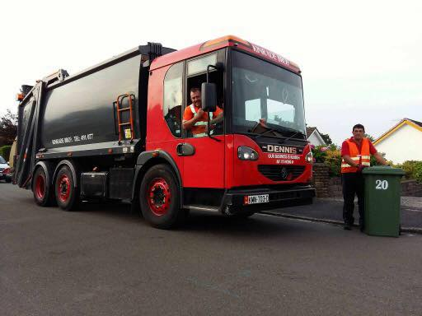
Refuse Collection
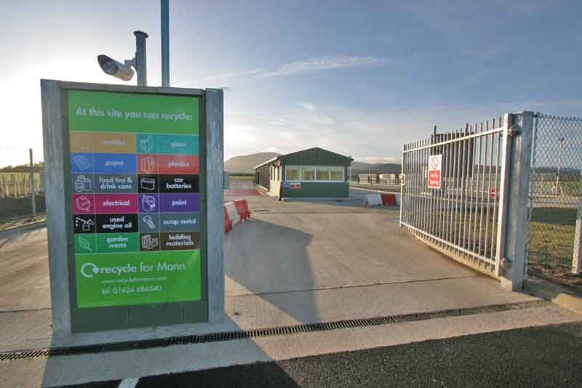
Civic Amenity Sites
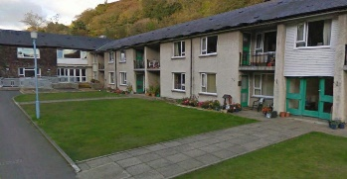
Sheltered Housing
Hedge-cutting & gulley
cleaning on minor roads

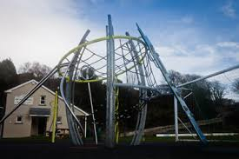
Play and Recreation Facilities

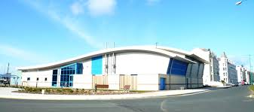
Swimming Pool Board
residents of Laxey will see a corresponding reduction. The overall rate income to the Authority remains at 2016/17 levels.
As you may be aware the most significant element of your domestic rates demand is for the water and sewage services provided by Manx Utilities which the Commissioners have no influence upon.
The New Garff Authority – How’s it working?
The amalgamation of the three authorities was always seen as a good fit as all three operated on a similar model; being one with very few directly employed staff, delivering the majority of services through the use of professional private contractors.
Other local authorities to north and south of Garff are modelled on a system of delivering services primarily through a much larger directly employed workforce. Laxey, Lonan and Maughold had always found that the use of contractors provided the most efficient and cost-effective method of delivering services and the Commissioners feel that, in the interest of the ratepayer, this model should be continued into the future.
Staffing
The Commissioners were very sorry to lose Robbie Dooley, a valued and very well liked staff member who passed away in 2017. Robbie was the Deputy-Warden at the Cooil Roi Sheltered Housing Complex and he is much missed by colleagues and residents alike. Lottie Moore has been appointed as the new Deputy Warden and is continuing Robbie’s good work
Additional Services?
As a principle, Garff Commissioners would be very interested in taking responsibility for a range of services, particularly first stage planning and public right of way maintenance for example. Any such transfers would have to be carefully considered and any possible financial impact measured and evaluated.
As with most things, your views on these matters would be very much welcomed.

Sheltered Housing – Cooil Roi and Ramsey
The Commissioners operate the Cooil Roi Sheltered Housing Complex in Laxey. The Commissioners also have a presence on the Northern Sheltered Housing Committee which operates several sheltered housing complexes in Ramsey. Further information on access to the facilities can be obtained from the authority’s Housing Manager, Julie Peel on 862307.
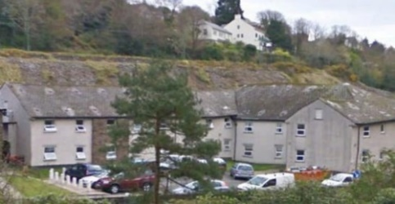

Public Sector Housing – Shared Waiting Lists
Residents of Garff seeking public housing are now able to choose to go on either a Northern or Eastern Area waiting list.
The Northern list provides access to the houses at the Corrany in Maughold, as well as giving the option to be housed in Ramsey or at any public housing location across the north of the Island.
Inclusion on the Eastern Area List provides access to public housing in Laxey, Lonan and Braddan.
It is hoped that Onchan will join the Eastern List at some point in the future which will bring further possibilities and increase choice for residents.
Nigel Dobson, Chairman of Garff Commissioners, said: ‘We welcome the opportunity to work with Braddan, the Northern Commissioners and the Department of Infrastructure. Shared waiting lists have been shown to have a positive impact in local communities and this initiative will increase flexibility and choice for all residents of Garff’.
If you wish to apply to go on the Northern or Eastern Public Sector Housing lists, please contact the Commissioners via garff@manx.net or on 861241 in the first instance.

Eastern Area Plan
The Commissioners have submitted their response to the Government’s Consultation on the Eastern Area Plan.
A display of mapping and of the proposals in the Commissioners’ Office proved popular and was visited by many residents during 2017. The response of the Commissioners was influenced by the comments made and covered the need for the provision of affordable housing, public sector housing and sheltered housing.
The submission also commented on the individual areas of land that had been identified as potential locations for development in the future. The response included general comment protecting the visual amenity and character of the Garff landscape as well as aspects of infrastructure such as sewerage, the road network and cycle routes. It is anticipated that government will report back on the consultation in the coming months.
Flood Risk – a continuing concern
Officers from the Commissioners meet frequently with Flood Risk Management Teams from both Manx Utilities and the DoI to discuss actions to mitigate against flood risk.
Manx utilities are currently updating their flood risk mapping database which will assist in identifying areas of risk and allow them to plan work to mitigate against flooding events.
The Commissioners continue to play their part through its road sweeping and gully cleaning operations on the secondary roads in the Sheading. In carrying out this work a number of problems with the drainage infrastructure have been identified and reported to the DOI. If you identify any blocked gullies please call the Commissioners on 861241.
Sewerage Improvements for Laxey and Garwick on the way
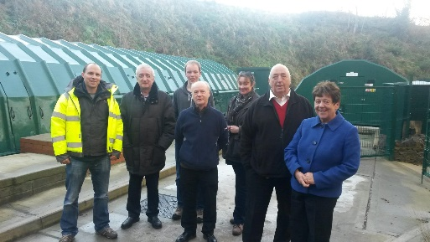
Laxey Bay is now the current focus for Manx Utilities with investigations taking place into treating the sewage that is currently emitted in a raw state at the Laxey and Garwick outfalls.
A close partnership has been established between Manx Utilities and the Commissioners through the works previously undertaken in Maughold and based on that experience the Board are very confident that a solution will be reached that works well for the residents of Laxey and Lonan.
A potential site in Laxey has been acquired and investigations are ongoing to assess the size and type of facility that is necessary. Suitable sites in the area of Garwick Bay are also being identified.
Full public consultation will take place once an initial proposal comes forward from Manx Utilities later in the year. It is anticipated that key areas for discussion will be mitigating visual intrusion and minimizing the effects on residents of any operational activity.
Road Safety
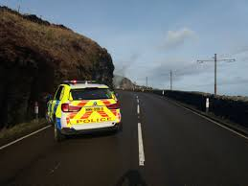
The Commissioners work very closely with both Highways and the Roads Policing Unit, and lobby the Department regularly about particular areas of concern such as around Ard Reart Junction in Laxey and Main Road, Baldrine.
During 2017 two further Speed Indicator Display (SID) signs were purchased by the Commissioners and are being deployed in these areas by rotation. The Commissioners also operate the Speed Indicator signs deployed at the entrances to Glen Mona. Feedback received suggests that the SID signs are proving very popular with residents.
The Commissioners are currently working very closely with the Roads Policing Unit and, in the coming weeks, hope to be able to announce some joint initiatives to improve road safety on the A2 Coast Road during the TT & MGP Festival Fortnights, particularly in areas such as Baldrine, Laxey, Bulgham, Ballure and Glen Mona.

Temporary Parking Restrictions in Laxey
Commissioners continue to be frustrated by the imposition of the Clearways in Laxey Village during TT, MGP and during periods when the Mountain Road is closed for maintenance. The Commissioners are aware of the difficulties this causes traders and residents and will continue to petition the relevant authorities to relax the restrictions as much as possible during these times.
Last year, the Commissioners negotiated a compromise where the Clearways were only in operation during peak times, but this was rescinded following communication from the police.

The restrictions may be temporary but the longer term harm to businesses in Laxey that they cause is a matter of great concern.

The Commissioners will continue to negotiate to improve the parking situation for borth residents and businesses.

Play Equipment in Lonan?

The Commissioners remain committed to providing adequate opportunity for children’s play in Lonan.
Planning permission has been granted for a ‘Trail’ type play area at All Saints Park for children in the vivinity between the ages of 8 – 14. It is expected that this equipment will be installed during the summer of 2018.
The Commissioners are awaiting a decision on their application to install play equipment for 2 – 12 year olds on the public open space between Church Close and Ballacannel which was taken to the appeal stage. If permitted this provision will be installed in the late summer of 2018.

Sports Facilities on Glen Road, Laxey.
The Commissioners are also in discussion with representatives from local sports groups regarding proposals to enhance the sports and leisure areas on Glen Road in Laxey.
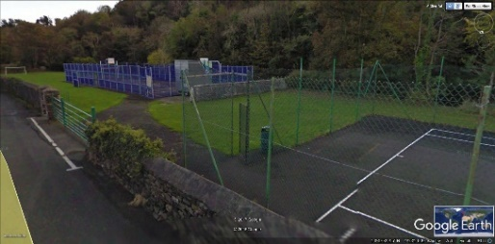
It is hoped that more details about these proposals as they develop over the coming year.
The Commissioners have also had requests to consider provide improved facilities for skateboarding. This is another aspect which they will consider during 2018.

The Future of Lonan Church?
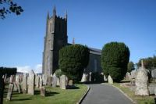
The Commissioners are investigating the possibility of taking over administration of the Lonan Parish Church Building with a view to using it as a base for community facilities and activities. It is possible that the building would also be afforded status as a “Festival Church”.
The Commissioners are obliged to follow the Local Government Petition Process which necesitates that a ‘needs assessment’ is drafted to identify whether there is a demand for a community facility in Lonan as well as to identify the activities that may take place there.
The Commissioners would welcome the views of residents in regard to identifying uses for the building that would provide a sustainable and viable community facility.
If you have a proposal for sporting or community activities that could take place in the building please let the Commissioners know via garff@manx.net or on 861241. Your input and ideas would be very much appreciated.

The Future of the Dhoon Church Field?
Another initiative being investigated with the Church Authorities is the use of the field beside the Dhoon Church for the Glen Mona and wider community. The Archdeacon has signalled agreement for an arrangement in which the Commissioners would take ownership of part of the field.
Initial suggestions are for the provision of children’s play equipment, and a ball sports area. It is felt that a portion of the field should be retained to enable staging of the Bonfire every November and that car parking facilities could be incorporated for public and church use. Monies for this project had been set aside by Maughold Commissioners and remain available to use for the benefit of the community. Once again, your views would be much appreciated on the types of facility that could be provided. Further negotiations with the Church Authorities are expected to take place in June 2018 in this regard.

Laxey & Lonan Heritage Trust Needs You!
L&LHT have been instrumental in ensuring that the areas heritage is presented in the most accessible and informative ways; facilities such as the Great Laxey Mine Railway and the Lady Eveline water wheel have greatly enhanced the profile of the village’s attractions.
If you are able to volunteer your time to any aspect of the Trust’s exciting and varied activities please call into the Heritage Shop on Mines Road, Laxey, or call 862007.

New Facilities in the Sheading
A range of new facilities are being commissioned or refurbished this year. These include:
- An updated street lighting scheme along Mines Road in Laxey.
- Extension of the streetlighting scheme on the A2 from the Church Road junction to Ballabeg Crossing.
- The beginning of a programme to upgrade all old street lighting in the Sheading to modern eco and light pollution standards.
- A proposal for new public toilets in Laxey Valley gardens
- Refurbishments to the Arboretum at Dhoon in Maughold.
- New children’s play equipment in Lonan.

Refuse & Recycling Information

A quick reminder that only general household waste should be deposited in your wheelie bin (as a rule of thumb, only materials that are easily and safely combustible. This will increase our recycling rates and improve the efficiency of the Energy from Waste plant in Braddan.
- The following items can be taken to a Civic Amenity Site (Middle River, Douglas or Balladoole, Lezayre):
- Batteries, Building rubble, Car and Motorcycle parts, Garden Green Waste, Fluorescent Light Tubes, Metals, Oil, Soil/Garden Stones, TV Sets/Electronic Goods/Phones, White electrical Goods, Large Tree Trunks/Branches
- The following items can be recycled at Bring Banks and the CA Sites:
- Cans, Glass, Paper, (cardboard, and plastic can also be recycled at Glen Rd, Laxey)
- For the following items you must seek specialist advice:
- Asbestos, Clinical Waste, Gas Cylinders, Medicines, Paint, Tyres.

Civic Amenity Sites
The Commissioners are represented on the committee recently set up to operate the Northern Civic Amenity Site at Balladoole, north of Ramsey. The site was previously operated by DOI, but is now under the direct control of the local authorities. Residents in the north of the Sheading who have used the site for several years will probably notice very little difference in the site's operation.
Arrangements for residents in Laxey and Lonan remain the same with the Eastern CA Site at Middle River being run by the Eastern local authorities including Garff.

Access to Public Libraries

All residents of Garff can access library facilities at the Henry Bloom Noble Library in Douglas free of charge.
Residents can also access the Family & Mobile Library in Douglas, and the library at Ramsey Town Hall: a small joining fee is payable to access these facilities.
A timetable for the mobile library can be obtained from the Commissioners (tel 861241 in the first instance) or online at: https://www.familylibrary.im/routes

Political Surgeries
The political Surgeries run jointly by our two MHKs and the Commissioners are proving both highly effective and very popular. Martyn Perkins, Daphne Caine and a Commissioner are in attendance to discuss any issues or concerns you wish to bring. The meetings take place across the Sheading at either the Commissioners’ Office on New Road Laxey, the Cooil Roi Housing Complex in Laxey, the Glen Mona Hotel in Maughold, or the Archibald Knox public house in Onchan.
Dates & locations as below:

May 12 Glen Mona Hotel 10.30 – 12.00
July 9 Archibald Knox Pub 17.00 – 18.00
Oct 6 Comms Office, Laxey 10.30 – 12.00
Nov 3 Glen Mona Hotel 10.30 – 12.00

New Commissioner – Maughold Ward!
The Commissioners are pleased to announce the election of Mr James Smith to the Garff Board.
James has lived in Maughold for 20 years, and works as a Software Developer in the Finance Sector. He enjoys walking and kayaking. James’ wife works in Baldrine and his children attended Dhoon School.
Speaking of his new role, James said, “I am eager to get involved as a Commissioner and ultimately do all I can to assist this lovely community. Taking Robert Moughtin’s place on the Board is a daunting prospect and if I can bring just a fraction of his passion and energy to the role, I will be very pleased”.

Contacting the Commissioners.
The Commissioners very much welcome the expression of views and comments.
Please contact Peter Burgess or Martin Royle at the Commissioners’ Office at garff@manx.net or by telephoning 861241.
The postal address of the office facility is:
Commissioners’ Office, 35 New Road, Laxey, Isle of Man, IM4 7BG
If your query is in relation to the Cooil Roi Sheltered Housing Complex, please contact Julie Peel on 862307.
Your Garff MHKs can also be contacted:
Martyn Perkins MHK tel: 651518
martyn.perkins@gov.im
Daphne Caine MHK tel: 651519
daphne.caine@gov.im

Watch out for!
“The Great Laxey Brass Band Festival”
Sunday the 6th of May 2018 – Laxey Village

Another Great Day Out in Laxey!

