Chairperson: Jill Furnival. 818229 Treasurer: Clare Christian 812152
Events Secretary: Pam Kerruish 815933
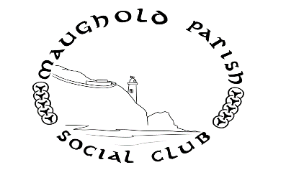

Newsletter December 2017

Nollick Ghennal as Blein Vie Noa!

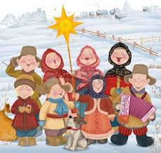

Friday 22nd December Carol Singing 6pm Glen Mona Bus Stop

Come and sing your heart out with our merry band. We will sing around the houses in the area (proceeds to Grove Mount Residential Home) and adjourn to the Glen Mona Pub when we have worked up a thirst.

Tuesday 26th December Hunt the Wren 10.30am Outside St Paul’s Church, Ramsey.
The custom of ‘Hunt the Wren’ has been observed in the Isle of Man since time immemorial. The ‘Wren boys’ meet on St Stephen’s Day morning (December 26) and stroll the streets carrying a gaily decorated ‘wren pole’ made from two wooden hoops intersected to make a cage for the poor little ‘wren’. Along the way, the group pauses to perform the traditional dance and sing the traditional song. It all ends at 12 noon when the usual practice is to seek out seasonal refreshments in someone’s front room or at a local hostelry.
The custom has been preserved in the north for a number of years by members of Maughold Parish Social Club. Once again, they invite you to join them at 10am outside St Paul’s Church. All are welcome – especially dancers, musicians and singers!! Any queries to Sue Woolley on 490054

Thursday 18th January “The Manx Bard” 7.30pm Dhoon Church Hall
This year the Manx Bard comes from Maughold! Come and hear her tell us about her role, show us her robes and, hopefully, recite some of her poetry.
Tickets. Members Adult £2.50 Child 50p
Non- members Adult £3.50 Child £1 Light refreshments.

Don’t forget that if you would like to put your name forward to serve on the committee next year please let Tina know by December 31st (current and new members- you will be welcome) tel 815804 or email tinahough@wimanx.net

Dates for your Diary.Tuesday 13th February Pancake Day
Tuesday 27th February MPSC AGM
Thursday 15th March Talk on Dumbell’s Bank by Alan Gelling

